### **2019 White House Christmas Stars - A Five-Point, An Eight-Point, And 3-D Star**

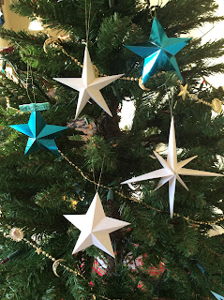

I saw a video of the the White House decorated for Christmas and I saw three stars that I wanted to recreate...a five-point star, an eight-point star and a 3-D star. Above is a photo of these stars on my Christmas tree.

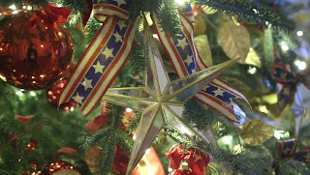

The first star is a traditional five-point star. This White House star looks like it was made out of glass. My star, of course, is made out of white cardstock.

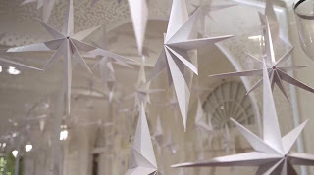

The second star is an eight-point star with two sizes of points. Here is a screen shot of the eight-point stars hanging from the ceiling at the White House.

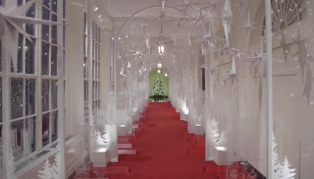

I love how the eight point stars adorn the White House hallway. My version has been resized so that you can put it on your Christmas tree. The third star is a 3-D star.

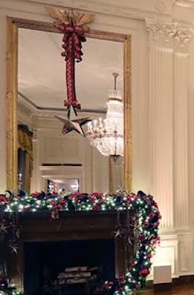

The 3-D star is hung over the fireplace at the White House. My version is for a Christmas ornament. However, you can resize my design to make it bigger if you want to hang the star over your fireplace.

Here is what the three stars look like closely.

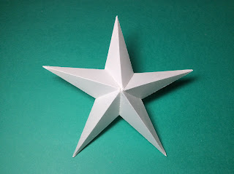

Five Point Star

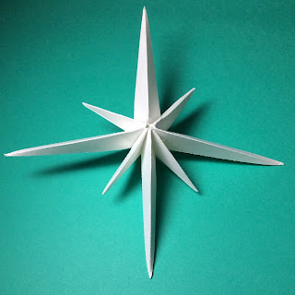

Eight Point Star

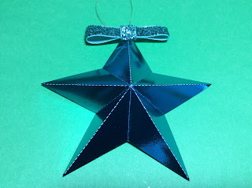

3-D Star

Please note, the five point and eight point stars are hard to make. They require patience and good gluing skills. The 3-D star is very easy to make.

Instructions to make the five point star:

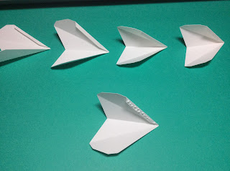

Fold all five points and apply glue to the tab as shown above.

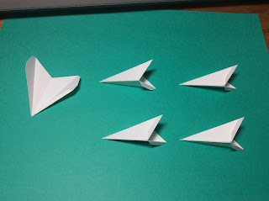

Adhere the tab. Make three more points. Do not glue the fifth point together.

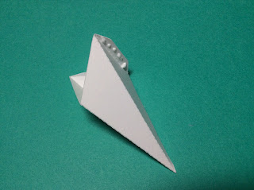

Apply glue to the underside of the tab on one side.

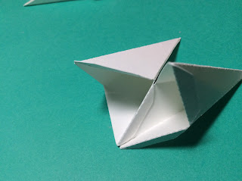

Adhere the tab to the inside of second point. First on one side.

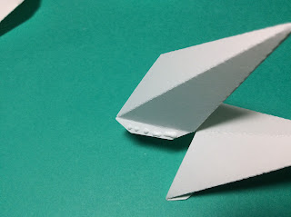

And then apply glue on the other tab and adhere to the other side of the second point.

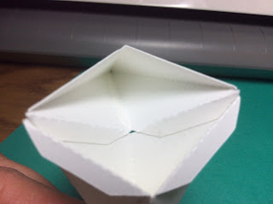

Picture of the inside of two points that were glued together.

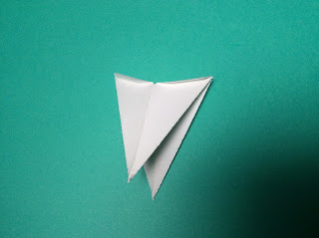

These two points can be folded down.

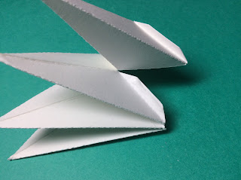

Adhere the third and fourth points in the same manner.

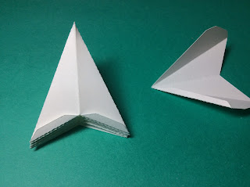

Four points glued together and the fifth point.

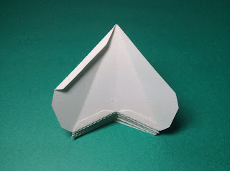

Slide and glue the fifth point to the tabs as shown.

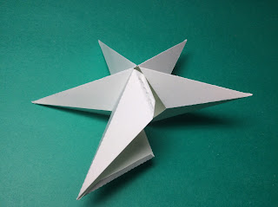

Fold the fifth point together and apply glue to all of the tabs. This is the tricky part. Make sure everything is aligned and hold the star until the glue dries successfully. You might have to reapply a small bead of glue to the edges to get everything to stick together.

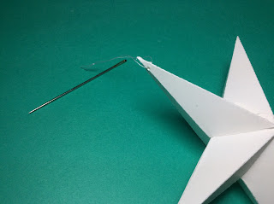

I added a string to the star using thread and a sewing needle to pierce the paper. I tied a knot to make the hanger for the Christmas tree.

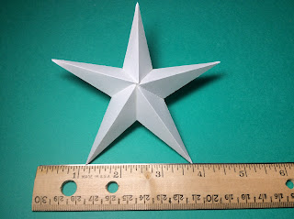

Completed five-point star

Instructions to make the eight-point star. The procedure to make the eight-point star is exactly the same as the five-point star with the additional points added alternating the big and small points. Leave the smallest point to be glued in last.

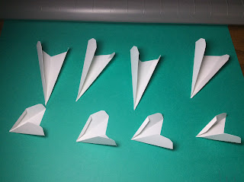

Fold all eight points. Set aside one of the small points. This will be the last point glued to the star.

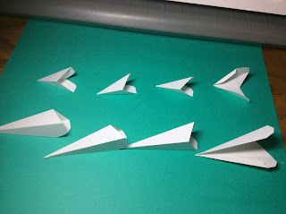

Glue all of the points except for the small point.

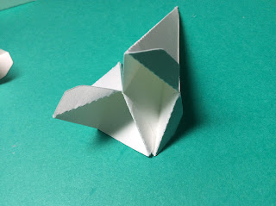

Glue and adhere a tab from one large point to the other small point.

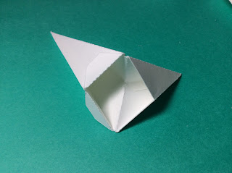

Glue and adhere the other tab.

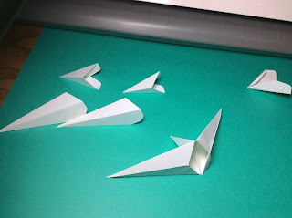

Continue glueing and adhering the two tabs of each point to the next successive point.

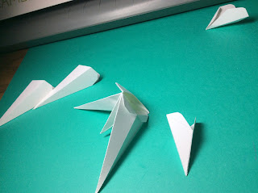

The points can be folded down.

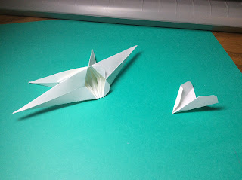

All the points have been added except for the smallest point.

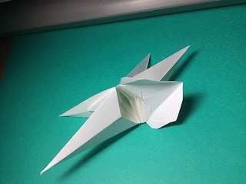

Glue the tab of the large point to this small point.

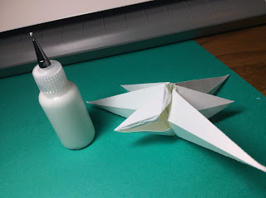

Apply glue to all of the tabs remaining on the small point and adhere into a small point. This is the tricky part. Make sure everything is aligned and hold the star until the glue dries successfully. You might have to reapply a small bead of glue to the edges to get everything to stick together.

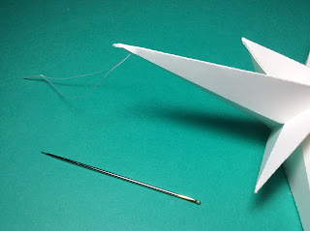

I added a string to the star using thread and a sewing needle to pierce the paper. I tied a knot to make the hanger for the Christmas tree.

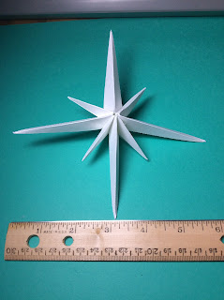

Completed Eight Point Star.

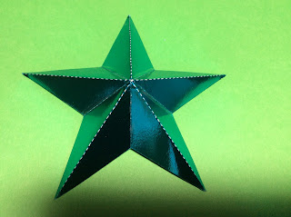

Instructions to make the 3-D star. Crease the star as shown above.

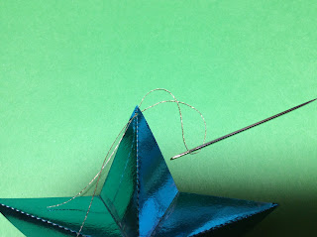

Using an eight-inch piece of string, thread it through a spot near the end of a star point to make a hangar for the ornament.

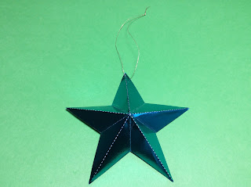

Tie a knot at the end of the string. The 3-D star looks very pretty at this point even without the bow.

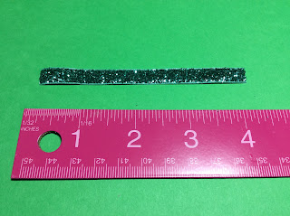

To make the bow. Cut a four-inch ribbon

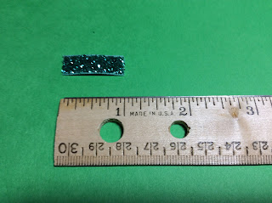

Cut a one-inch ribbon.

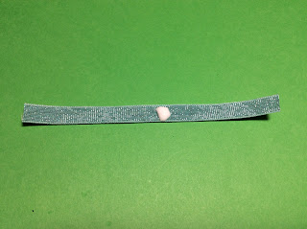

Apply glue to the center back of the four-inch ribbon. Fold the ends to the middle of the glue spot.

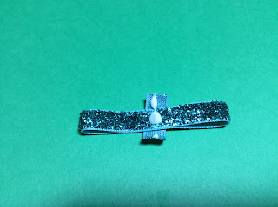

Wrap the one-inch ribbon around the bow and adhere the ends to the back of the bow. Glue the bow to the star point where the string is located.

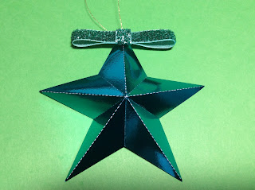

Completed 3-D Star Ornament

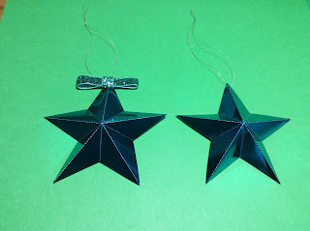

3-D Ornaments with and without the bow. Both look beautiful!